**SUFFOLK CHAPTER**

**KNIGHTS OF COLUMBUS**

**OVERVIEW of PROGRAMS**



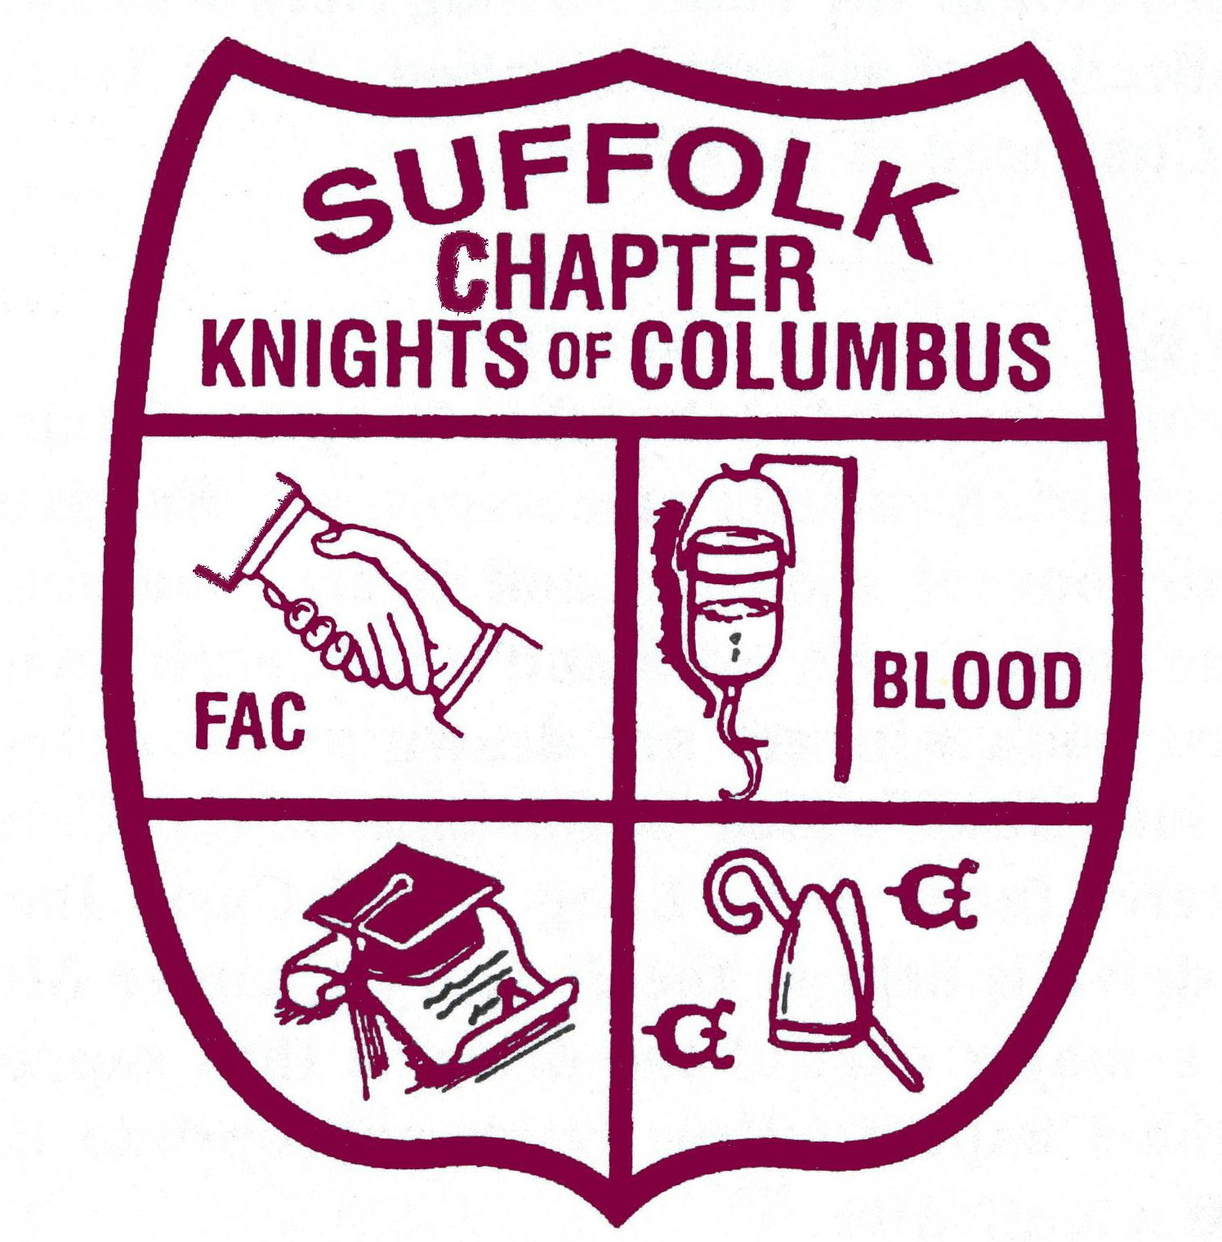

**Michael Boehm**

**Chapter Chairman**

**July 2020**

My Brother Knights:

The following information is provided to apprise you of what services, events and committees are available to serve your council and you as a member of the Suffolk Chapter, Knights of Columbus:

All brother Knights who are members of Councils located in Suffolk County, NY are entitled to what is being presented in the following pages.

**COMMITTEES REPORTING DIRECTLY TO CHAPTER CHAIRMAN**

FRATERNAL ASSISTANCE -- Current Chairman: THOMAS f. fAWCETT, sR. PGK

Committee chaired by Vice Chairman of the Chapter, per bylaws. Staff of 5 investigators report to the Vice Chairman. Program was established to provide assistance to the Knights of Columbus, Columbiettes and members of Ladies Auxiliaries or their spouses, children or other relatives legally dependent upon such member for their support. Maximum grant in any six (6) month period is $600 (six hundred dollars). Council must first approve and request on behalf of member. Program funded entirely by our raffle program and Direct Donations. Per Chapter bylaws, Outside Guard is the administrator of the Fund Raising Networks and the FAC Treasurer is responsible for collection of all monies raised. FAC Treasurer is approved by Chairman and Vice Chairman of the Chapter.

FOOD FOR BROTHERS - Current Chairman – TOM ROMANO FDD, PFN, PCC

This program offers immediate assistance to Brother Knights in Suffolk County who need help in providing food for themselves and their Families. Upon receiving a request from a Grand Knight the Chairman will take action in sending aid to the Brother Knight, usually, in the form of a supermarket gift card.. This Program is a multi level Program that is supported financially not only by the Suffolk Chapter by both the Suffolk Conference and the NYS Council.

CHARITY DRIVE -- Current Chairman: Paul J. Diorio PGK, DD

Headed by a chairman appointed by the Chapter Chairman with about 20 committee members chairing various subcommittees. Funds are collected through award books, souvenir journal, sponsors, and direct donations. The Charity Ball is the culmination of the committee’s work and is held each spring at a large catering hall or hotel. Award book winners are drawn at the Charity Ball. Some other programs continue into June which is the end of the Columbian year. Some benefactors who have received funds are: Long Island Cares Inc., Sunrise Fund, etc. The kickoff for the drive is held at the January Chapter Meeting. Columbiettes and Auxiliaries are a major part of the drive as they support all programs and work closely with the Chapter. Usually an appropriate theme is used to help stimulate the drive as a motivator.

FRATERNAL ACTIVITIES -- Current Chairman: THOMAS A. ROMANO PGK, FDD, PFN, PCC

Committee staffed by chairman and the advisor, who is usually a past chairman. The purpose is to schedule and promote activities and events for Chapter members, families and guests to socialize and relax in a fraternal atmosphere. Any profits are turned over to the Chapter treasurer for Chapter use.

BISHOP’S MEMORIAL MASS -- Current Chairman: William P. Murphy PGK, FDD

Committee of chairman, secretary and advisor, as well as various subcommittees dealing with parade, reception, ushers, publicity, and installation of Chapter officers. A necrology coordinator is also an important part of the committee to create a program listing deceased members’ names gathered from councils’ submissions. Committee starts to meet in July or August to plan Program and Liturgy for Mass . Donation usually presented to the Bishop at conclusion of Mass. A Past Chapter Chairman is usually Mass Installation coordinator. Honored guests usually include State Family, District Deputies, Past Chapter Chairmen, Escorts, Faithful Navigators, Master, Honor Guardsmen, Columbiette Supreme, State and Chapter Officers, Columbiette Auxiliary Presidents and Ladies Auxiliary Presidents. Site of Memorial Mass is chosen by Chapter Chairman each year.

CHAPTER DIRECTORY COMMITTEE -- Current Chairman: NORMAN A. WAGNER PGK, FDD; ROBERT ROONEY, PGK, FDD

Function is to gather all “hard” data from all levels of K of C such as Supreme, State, 4th Degree, Chapter, Councils and Districts. After information is gathered, it is forwarded to the directory programmer who inputs to the computer generates a draft copy for the printer. All input data must be received by June 30th. The Chapter Directory is distributed at the August Indoctrination meeting or the September Chapter meeting. Extra directories may be purchased for a nominal charge (currently $8). Chapter Chairman’s Staff (with committee) handles distribution.

CHAPTER PROGRAM DIRECTOR -- Current Chairman: WILLIAM MONROE PGK, FDD

The directors within the Suffolk Chapter are to help facilitate meetings of the Chapter by contacting various chairman under their directorship to see if it is necessary for them to make reports at a Chapter meeting. Generally, reports should be no longer than five minutes. The directors are appointed annually by the Chapter Chairman. The directors report to the General Program Chairman.

CATHOLIC ACTIVITIES -- Current Director: William P. Murphy PGK, FDD

KEEP CHRIST IN CHRISTMAS -- Current Chairman: BOB BIENEMANN, CARLO BUSCEMI

The committee is headed by a chairman who promotes the theme of “Keep Christ in Christmas,” by selling items such as magnetic bumper stickers, sweat shirts, aprons and the like. Usual cost is nominal such as $3-5 for small items; shirts and aprons are competitively priced.

FATHERS FOR GOOD - Current Chairman: ROBERT LOPEZ PGK

Welcome to **Fathers for Good**, an initiative for men by the Knights of Columbus.

Whether you are a seasoned dad, a new dad, a dad to be, or a single guy wanting to know more about fatherhood, this program is for you.

There is a role only a father can fill and gifts only a father can give. In a culture that often does not favor fatherhood or masculine virtue, we wish to highlight the unique contributions of men, husbands and fathers. The world would be lacking without them.

MISSIONS -- Current Chairman: ROBERT F. MURRAY PGK, FDD, PFN

Chairman collects soap, eyeglasses and medical bandages to send to missions in countries where need of these items is very high. The chapter pays postage to send supplies. Also can tab Chairman.

VOCATIONS –- Current Chairman: WILLIAM P. MURPHY PGK, FDD

Chairman coordinates reception with the seminary and seminarians who are studying for the priesthood or women who are studying to be nuns. Usually on a yearly basis a day at the seminary is held for Grand Knights to meet the people they sponsor. Financial support is most important as is moral support to seminarians. Program works in conjunction with Supreme’s RSVP program. The Chapter budgets money yearly for vocation sponsorship. Check is presented at Chapter meeting. Chairman advises delegates to support vocations at all meetings.

LIAISON TO THE SHRINE -- Current Chairman: WILLIAM P. MURPHY PGK, FDD

Co-chairmen from both counties coordinate State Shrine Pilgrimage with Suffolk Chapter as event is held on same day at Our Lady of the Island Shrine in Eastport, L.I. Our Chapter Chaplains preside over the Mass. The Suffolk Chapter Chairman, N.Y. State Deputy, and N.Y. State President of Columbiettes (if present) handle readings at Mass. The Chapter uses this occasion to present its annual donation to the Shrine. The Shrine facilities include a gift shop, rosary walk, Stations of the Cross and picnic grounds.

TRAVELING MADONNA -- Current Chairman: RICHARD WEBER PGK

Chairman is responsible for caring for the statue of Mary (i.e. Traveling Madonna). Councils will borrow the statue for usually a month for various activities and bring it back to the Chapter meeting on the following month to lend to another council.

PROGRAMS FOR LIFE -- Current Chairman: PETER BERTRAN

Chairman keeps Chapter delegates apprised of any Pro-Life legislation activities and events upcoming in Columbian year. Encourages Chapter delegates to attend January Pro-Life events, such as Pro-Life Mass at St. Patrick’s Cathedral, the March for Life in Washington, DC and other state-sponsored events. Chairman acts as liaison for Chapter to Birthright for council donations to be made at Chapter meetings and forwarded to Birthright. Chapter makes yearly donation to Birthright at annual meeting. Some requests are made for members to help at parades and demonstrations to ensure order is kept. Demonstrations are held regularly at various abortion clinics (including Processions for Life at churches) throughout Suffolk County.

CATHOLIC ADVOCACY -- Current Chairman: WILLIAM P. MURPHY PGK, FDD

Chairman to raise awareness on any anti-Catholicism events that may transpire in the media or in society as a whole or within the region. Committee may respond as events happen by organizing campaigns for letters, phone calls, and demonstrations. However, proactively the committee can spread the Christian message far and wide so our opponents “Think before they act.”

FRATERNAL – YOUTH ATHLETIC ACTIVITIES -- Current Director: MICHAEL HEARNEY PGK, FDD

All Youth related activities including but not limited to the Annual Track Meet fall under this Director.. Arrangements usually include getting permission from a local school for use of track and field and rest rooms. A food committee is essential to get hot dogs, rolls, condiments, etc. Medals and ribbons have to be ordered for awards to be given to children. Events include dashes, long jump, meter relays and sometimes a Squire event. Committee of about 40 to 50 people needed to properly run the meet, staff finish line, serve food and other activities. Day usually starts at 9 A.M. and ends at 3 P.M. The 4th Degree Honor Guard should be contacted to conduct the opening ceremony and Pledge of Allegiance. CYO coaches and children are an integral part of the meet. Hats or shirts are given to workers.

YOUTH COMMITTEE -- Current Chairman: THOMAS A. ROMANO PGK, FDD, PFN, PCC

This committee functions to foster and help the youth programs in Suffolk County. Major activities include the Free Throw Contest and Squires Circle publicity. The Suffolk County Conference on Youth was established years ago to coordinate Squire activities.

HIGH SCHOOL ASSISTANCE - Current Chairman: ROBERT DOBRES PGK, FDD

Chairman and judging committee screen applications for assistance to Catholic High School every year by May 1st and 15th. Scholarships are granted annually. Checks are awarded to the scholarship recipients upon graduation from grammar school. (See attached Rules/Procedures for committee.) Annual budget of $5,000 is appropriated by the Chapter.

COLUMBIETTE LIAISON -- Current Liaison: JOHN MASTROSIMONE PGK, FDD, PFN

Appointed to represent the Chapter at monthly meeting and ceremonials and to report on Suffolk Chapter activities to the Columbiettes and report back to Suffolk Chapter members on the Columbiettes’ activities.

NEW HAVEN TRIP -- Current Chairman: gENE jOHANN PGK

Chairman to put together and publicize A trip sponsored by the Chapter for members and families.

SPECIAL FUND-RAISING -- Current Chairman: CARLO BUSCEMI

Chairman at Chapter meetings sets up tables with various items for sale such as hats, shirts, patches, pins, sweaters, etc. Money turned over to Chapter treasury to support programs.

KNIGHT OF THE YEAR -- Current Chairman: WILLIA RATZSCH PGK, FDD, PST, PSA

Chairman prepares and coordinates program to present award to “Knight of the Year.” Chapter Chairman selects the recipient after getting input from Chapter officers and staff. The award is presented at the August Chapter meeting and the honoree’s family is invited to participate.

GOLF -- Current Chairman: GENE JOHANN

A new twist on an old Program. More information To be announced.

PUBLIC/COMMUNITY RELATIONS -- Current Director: JOHN MASTROSIMONE PGK, FDD, PFN

CHAPTER BULLETIN -- MICHAEL TULLY PGK, FDD, PFN, EDITOR

Editor receives articles to publish and mail out monthly bulletin 12 times a year. Input from delegates is essential to put out a newsworthy bulletin on a timely basis. Chapter dues from local councils must be paid for delegates to receive bulletin. Monthly Chapter meeting is deadline for article input to editor. Editor is also responsible for preparing press releases for major Chapter events and activities for publication in Long Island Catholic and other Long Island newspapers, as well as radio and television stations.

COUNCIL BULLETIN CONTEST -- Current Chairman: CHRISTOPHER BEATTIE PGK, FDD, PFN

Chairman expected to receive six bulletins between October and April of Columbian year. Judging is done by an impartial panel and top three places are then awarded in the county at June or July meeting. One item that is key to the winning bulletin is the inclusion of Chapter news and information to local support for Chapter programs.

HISTORIAN -- NORMAN A. WAGNER PGK, FDD, S.A.

Job is to keep updated history of the chapter and publish interesting items of note in Chapter bulletin when relevant PHOTOGRAPHER -- TBA

Committee of one who takes pictures at Chapter sponsored meetings and events. Distributes pictures to those photographed. Take pictures of Charity drive events every year including VIPs at the Charity Ball. Helpful to Chapter bulletin editor to input photos on activities.

COMPUTER COMMUNICATIONS – KEVIN DRAWBRIDGE

This committee’s purpose is to help councils with better communication through e-mail and utilization of the internet. Goals include helping to establish websites for various councils through K of C online. Many councils throughout the Order are already online and find it extremely beneficial. Computer communication is key to the Chapter’s future success. Our home page is [www.suffolkchapterkofc.org](http://www.suffolkchapterkofc.org)

Go here to find up to date information on the Chapter and ALL Chapter Forms.

BLOOD DRIVE -- Current Chairman: JOHN T. FINN PGK, FDD

Chairman heads committee to liaison between councils and Long Island Blood Services, providing information on council drives as well as the need for blood. The chapter gives annual awards to councils who donate the largest number of pints. Grand Knights should furnish council chairman’s name to Chapter blood committee chairman for his records and to coordinate blood drives.

OTHER CHAPTER EVENTS AND INFORMATION:

INTER-CHAPTER MEETINGS -

Meeting held once a year, hosted by one of the seven downstate chapters on a rotating basis. It is an opportunity for our chapters to come together over dinner and share our ideas and programs. Usually Chapter Chairman and officers attend.

ADVISORY BOARD OF THE CHAPTER - THOMAS A. ROMANO PGK, FDD, PFN, PCC

Staffed by chairman, officers and appointees from within Suffolk County to deliberate on various Chapter matters such as the budget, and various programs with which the chapter may become involved. Advisory board is just that, advisory in nature. The membership always has the final say. Meets on a quarterly basis per chairman calling meeting.

LIVING ROSARY - WILLIAM P. MURPHY PGK, FDD

Purpose is to coordinate the reciting of the living rosary at Chapter meeting once a year in May. Large rosary is opened up and prayer is usually led by the Chapter Chaplain or Associate Chaplain.

INSTALLATIONS – MICHAEL BOEHM PGK, FDD, CC

Chapter chairman may also attend many functions and events such as installations, testimonials and socials when invited by local council leadership to do so. Other Chapter Officers may be asked to fill in from time to time if the Chapter Chairman is unavailable.

DRESS OF OFFICERS -

A merlot jacket, white shirt, coordinated tie, black pants, black socks, black shoes, jewel and badge always appropriate at all Chapter functions for Chapter Officers unless otherwise specified. Chairmen and Directors should wear a Chapter Polo shirt when possible.