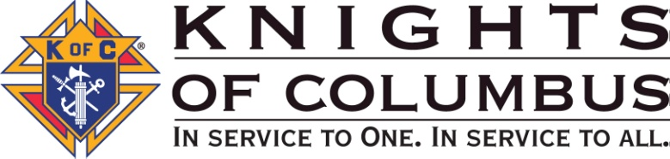

Suffolk Chapter Knights of Columbus
Blood Drive Donation Report
July 1, 2020- June 30, 2021

- Council Number and Name ____________________
- Grand Knight ____________________
- Blood Chairman and Phone ____________________
- Date of Blood Donations ________
- LI Blood Services Group ID ________
- Number of Registered Donors* ________
- Number Deferred ________
- Number of ALYX donors ________
- Whole Blood Donors ________
- Total Units Donated ________
- Did Any Donors use Your Local Blood Services Sites to Donate? (y/n) ____
- Did they use your Group Number for that Donation? (y/n) ____
- How Many donations of Platelets were made at the Blood Services Site? ____

Upon completion of your Blood Drive, please complete this form using the information on the Blood Center receipt given by the LIBS on site supervisor and send to:

fisharm747@msn.com (preferred)
or via US Postal Service to:
John T Finn PGK, FDD
30 Berard Boulevard
Oakdale, New York 11769-1709

Thank you for being a blood donor or group leader

